**MYSQL SIDE BEFORE ADDING NEW PRODUCTS OR USERS.**

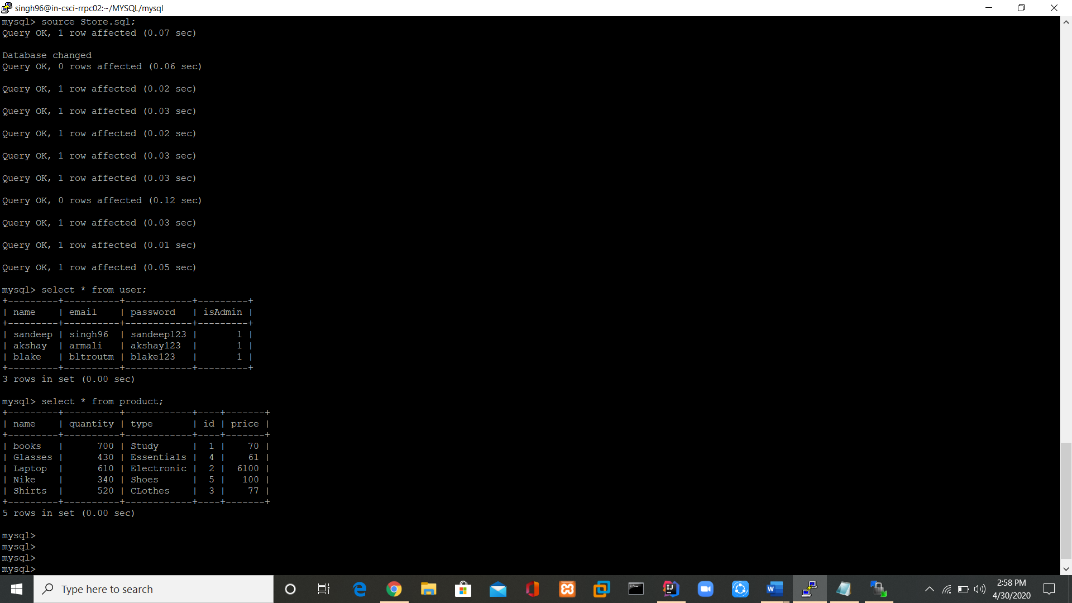

Logging into server, client and mysql using RRPC02 machine.

Source file is Store.sql

**AFTER ADDING NEW USER AND PRODUCT INTO TABLE**